**Bringing Another Professional Sports Team to San Antonio**

**Adam Alder**

**July 3rd, 2021**

**1. Introduction**

**1.1 Background**

Professional sports in many people’s lives are as important as eating breakfast. It gives them the ultimate satisfaction and joy they need to get through everyday life. Most large cities embrace this by having multiple professional sports teams in their city for people to enjoy and help them relax in times of need. When looking at the top seven largest cities in the United States, something appears to be unusual though. All the cities have multiple professional sports teams expect one and that city is San Antonio, TX. This report is going to start off with a comparison of these largest cities as far as population and how many professional sports teams are in these cities. It will continue with an overview of San Antonio and why San Antonio is a great location to add another professional sports team. Finally, the report will look at potential attendance and revenue for an owner looking to bring in a Major League Baseball team to San Antonio.

**1.2 Problem**

The people of San Antonio are being deprived of professional sports in their city. Right now, there are the San Antonio Spurs (NBA) and nothing else. The best areas to explore when looking into adding a sports team to a city are the location, population and land area. We need to make sure there will be enough people interested, in a great location, with plenty of land to build a stadium. San Antonio checks all these boxes.

**1.3 Interest**

Potential professional sports owners and sports owners looking to change locations to improve revenue would be interested at looking into San Antonio as a city to either start a professional team or to move a professional team. The city of San Antonio would also have an interest because there is potential to bring in more people into the city which in turn would bring more money into the city.

**2. Data Acquisition and Cleaning**

**2.1 Data sources**

To get the data that I needed I used multiple websites. To do the population and sports teams per city comparison I used websites <https://en.wikipedia.org/wiki/List_of_United_States_cities_by_population> and <http://www.stadium-maps.com/facts/sports-franchises.html>. To look at San Antonio as a great location for another professional team I used Foursquare and <https://sanantonio.areaconnect.com/zip2.htm?city=San+Antonio>. Finally, to see potential attendance and revenue I used <https://www.morssglobalfinance.com/major-league-baseball-finances-what-the-numbers-tell-us/>.

**2.2 Data cleaning**

There are some great tables in these websites but scraping them proved to be challenging. To start, I was able to scrape the population table within the most populous cities in the United States Wikipedia website. Once I had this table scraped, I was able to clean it and get the information that I needed. Most importantly, the population and land area information.

Next, I used the San Antonio zip codes website and Foursquare to look at San Antonio as a city. The San Antonio zip codes table provided me with the zip codes I needed plus the latitude and longitude of the different parts of the city. Unfortunately, getting this table into my report wasn’t as easy I had hoped. I had to create a new table because the table on the website had a security lock and it wouldn’t let me scrape it. The Foursquare website helped me look at different venues within the San Antonio neighborhoods and gave me a better idea on where a stadium could be built.

Finally, I used the Major League Baseball finances website to get information about the attendance and revenue of the top six largest cities in the United States. I took this information and created two new columns and added them to the population table. From here I computed the averages of the attendance and revenue columns to give an estimate of how many people and how much revenue potential there could be for potential owners thinking about starting or bringing a professional team to San Antonio.

**2.3 Feature selection**

After data cleaning, I was left with three main tables and Foursquare information to use in this report. The first table had three hundred and seventeen rows and five columns. The rows are showing the most populous cities in the United States in order from largest to smallest and the column attributes are rank, city, state, population and land area. I only used the first seven rows of this table for my analysis.

The second section of the report includes the second table created along with the Foursquare information. The second table consists of twelve rows and five columns. The rows have information on the different neighborhoods in San Antonio by zip code. The column attributes are zip code, county, neighborhood, latitude and longitude. The Foursquare information goes over the different venues in San Antonio. It has eight rows and seventy columns. I did a top ten per neighborhood venue analysis from this information.

The final part of the report uses a table that has seven rows and six columns. The rows again are by population rank but this time the column attributes include rank, city, state, team, attendance per game and yearly revenue in millions. I was able to use the information provided to make an estimate on how much a potential owner could make in revenue if their team were to be in San Antonio.

**3. Exploratory Data Analysis**

**3.1 The comparison**

My research started with a simple question. Why does the city I live in only have one professional sports team? It got me thinking about how other large cities compare with San Antonio when it comes to professional sports teams in these other big cities. What I discovered was astounding. Of the top seven most populous cities in the United States, only San Antonio had one professional sports team. The other six cities had at least four teams with New York having the largest number of teams with eleven.

So, you might ask, why include land area in your table. Well population is only one factor here. We need people to go to games but we first must have enough land to build a stadium where the games can be played. Of these top seven, San Antonio has the fourth largest land area. As you can see, San Antonio has the population and the land area to support another professional team in the city.

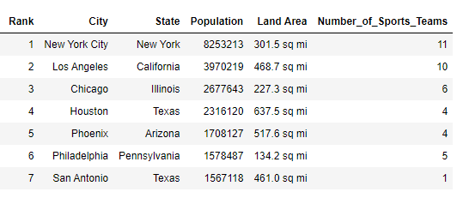

**Results:**

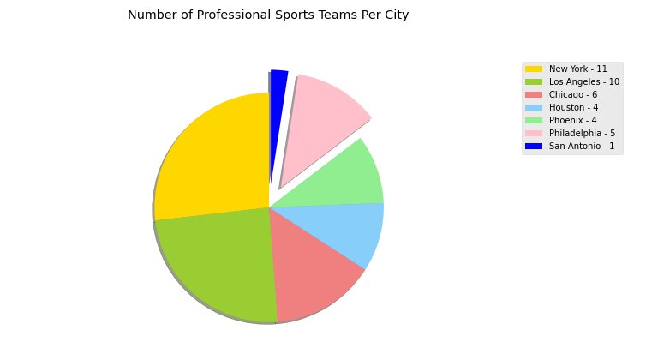

To me the results here are very interesting. I can understand why New York or Los Angeles would lead the way with the number of professional sports teams. What is surprising is if we compare Philadelphia and San Antonio. Above I extracted those two pieces so we can get a better view. Between those two cities there are six professional sports teams. Philadelphia has five and San Antonio has one. The interesting thing here is that Philadelphia is ranked as the sixth most populous city right above San Antonio and only has a little over eleven thousand more people. If we look at land area, San Antonio has over three hundred square miles more than Philadelphia. Yet Philadelphia has four more professional sports teams than San Antonio. From these results we can see San Antonio definitely deserves another professional sports team when compared with the top populous cities in the United States.

**3.2 Location, location, location**

Any entrepreneur starting a business has location as one of the most important factors to look into before starting that business. San Antonio is a large city with a small city feel. It is considered one of the best tourist destinations and has many things to do including the River Walk, the Alamo, SeaWorld, Six Flags, etc. One that I didn’t mention yet is the San Antonio Spurs. The only professional team that San Antonio has. The city cherishes the Spurs and I could see them doing the same with any other professional team brought into the city.

With Foursquare I was able to look at the different venues throughout San Antonio and formed five clusters which allows us to see the best spot to build a stadium. Finding a spot where there is enough land to build, that is safe and has a fun surrounding environment are most important. Also finding a spot with easy access in and out would be beneficial to the fans.

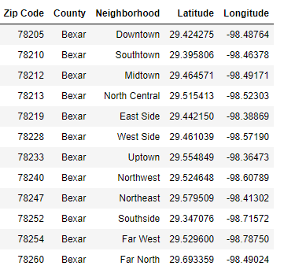

**Results:**

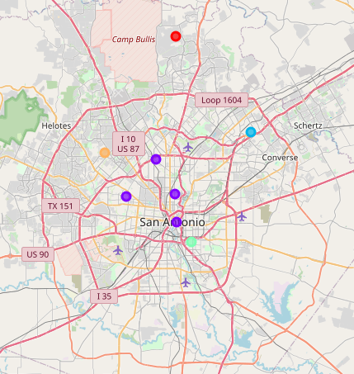

When it comes to location for a stadium there are a couple good options in San Antonio. If we take a look at the above map, most venue clusters are centered near downtown. The issue with downtown is the River Walk goes directly through it so that would not be a good area for a stadium. We also don’t want to get too far out. As you get to locations like Helotes and Schertz, there is land but there are not many things to do. You would have the stadium and nothing else which isn’t really ideal. The other factor we have to look at is proximity to the airport since the players will need to fly in and out of the city. On this map there are several airports listed. The main airport, San Antonio International Airport, being in uptown central downtown.

With all of this being said, I believe there are two location spots that would work best to build the stadium in San Antonio. The first spot, is on the East Side. This spot might not have many venues but it is a spot that already has a stadium for the San Antonio Spurs. Some cities like to have a combined area where they will build multiple stadiums and make it into a small city of its own. This is something they could think about here in San Antonio. The second spot that I would suggest is the West Side if they are looking to not have the stadiums so close. The West Side has enough land to build and is closer to the downtown cluster of venues. Whichever location potential owners would pick would work out just fine. There is plenty of space, plenty of loyal fans, and access in and out of each area would be easier with multiple highways for people to choose.

**3.3 Play ball!**

The third and final thing I wanted to look at was the potential revenue that an owner could bring in by having a team in San Antonio. My research focused on bringing a Major League Baseball team to San Antonio but any professional team would be welcomed. To research potential revenue, I took my original population table and added two columns. One for attendance and one for potential revenue. There are many things that go into revenue but the major source of revenue is the fans so attendance would be important.

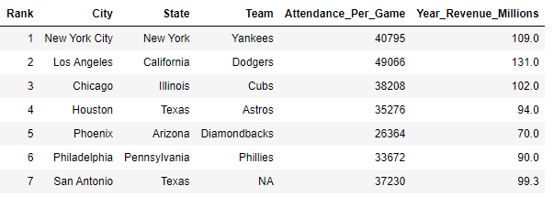

**Results:**

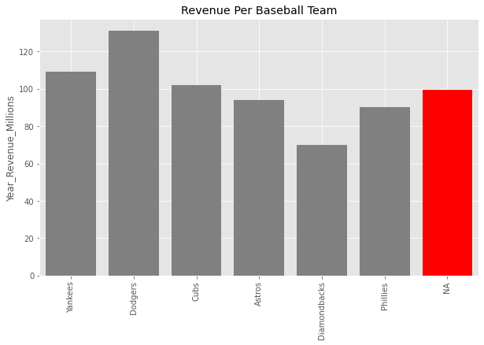

Ok so we now know that San Antonio would be a great place for another professional sports team when it comes to population and location but what about potential revenue? I decided to go with potential revenue if the owner was looking into a Major League Baseball team. To get an estimate I took six baseball teams. One from each of the six most populous cities in the United States. As the bar chart above shows, if a team was brought into San Antonio and able to at least reach the average revenue of what the other cities brought in, the potential owner is looking at approximately 99.3 million dollars per year.

Now this might not be a great comparison because some cities might have a large population but interest in sporting events might not be that high. So, let us look at a statistic that might help ease your mind. In the 2019/2020 NBA season, the San Antonio Spurs had an average attendance of 18,350 with a whopping 255 million dollars in revenue that season. The city of San Antonio is a very loyal fan base and this statistic proves this. I feel this shows that any potential owners wanting to start a team in San Antonio should not be afraid about potential revenue.

**4. Discussion**

So, what do you think? Is San Antonio a great place for another professional sports team? Do San Antonians deserve another team? I would answer yes to both those questions. San Antonio has the population and the land area to welcome another professional team. San Antonio also has loyal fans and have proven this with the one professional sports team that they do have. San Antonio loves their Spurs. I am a San Antonio transplant. Not originally from here but I can really see how supportive the fan base here is and they really do deserve another professional team to root for.

There are a couple of different routes that can be taken if/when another professional sports team owner selects San Antonio as there home. The first route would be to start from the ground up and be a part of an expansion. This would involve having a new owner that would build a team through a draft of players. This usually entails drafting current players already on a team or drafting players in an amateur draft. The second option would be for a current owner to bring in a team from another city. Maybe a change in scenery is needed to create better revenue for the team. This would be disheartening for die hard fans in the city losing their team but just like anything else professional sports is a business and owners need to make profits.

**5. Conclusion**

In conclusion, I hope you see that San Antonio would be a great fit for another professional sports team. It is a city that would give any potential owner a perfect location, a perfect fan base and a chance at a very promising earning potential. Potential owners would have everything they need here in San Antonio.

In the first part of the report, I presented the problem of depriving San Antonio of sports entertainment by only having one professional sports team in the city. The sports fans of San Antonio deserve more. They are a very loyal fan base and have proven this by how they treat the Spurs.

The next part of the report focuses on the actually research and data that shows San Antonio is a great place to start or have another professional sports team. I looked at three different areas. How did San Antonio compare to other populous city in the United States, is San Antonio a great location to start a team and what could be the potential revenue for an owner wanting to start or move a team to San Antonio. All the results pointed to San Antonio being a perfect location for another professional sports team.

The end of the report includes a discussion and wraps things up. During the discussion I mentioned a couple different options for potential owners. The first option was to start from scratch and build a team through expansion/draft. The second option was to move a team from a different city to San Antonio in an attempt to produce more revenue. Both options would be great options for the people of San Antonio and any potential owners.

I hope you enjoyed this report and agree with me that San Antonio deserves another professional sports team. It has the right amount of people to keep attendance high, it has the land to build a stadium and it has high earning potential for any owner. Maybe in the future this will be an option for the city of San Antonio. As for now, we will have to keep cheering for the Spurs!

